Pattern Matching
AIM:
To write a Prolog program to implement pattern matching and identify matching patterns using logical unification.

ALGORITHMS:
- Start.
- Define the input pattern and the data to be matched.
- Read or specify the pattern and input data.
- Compare the pattern with the input data.
- Use Prolog unification to match corresponding terms or variables.
- If the terms match, return success and display the matched values.
- If they do not match, return failure.
- Use backtracking if alternative matching rules or solutions are available.
- Stop.

CODE: 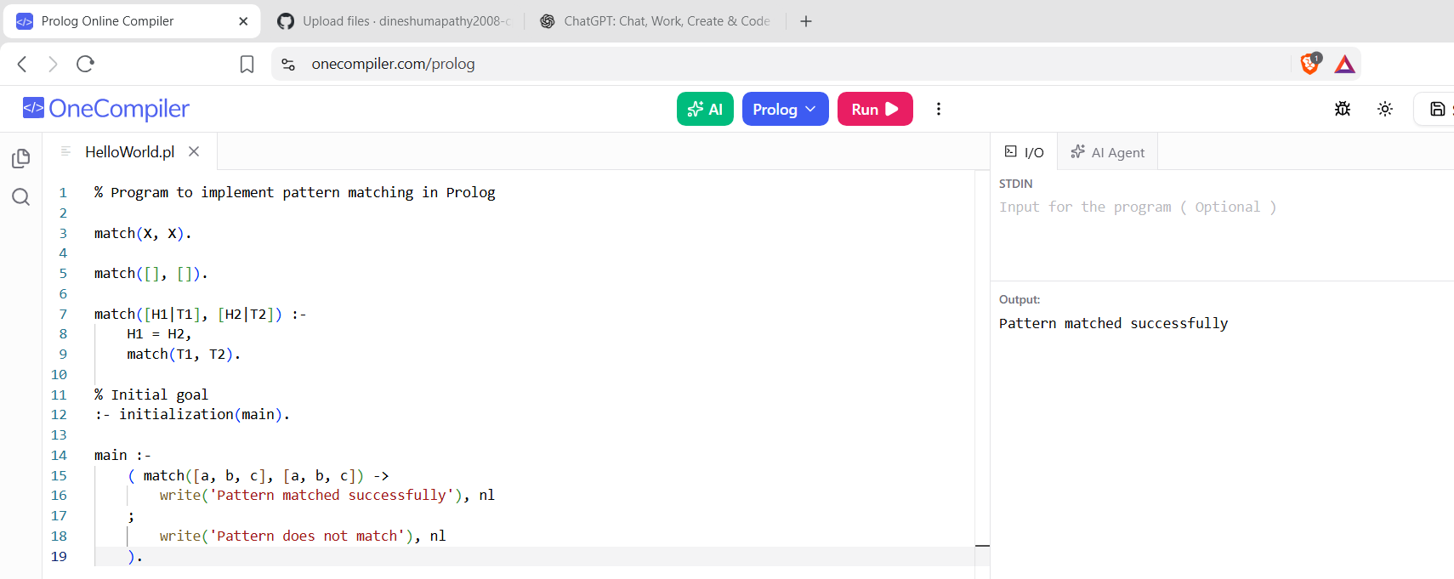

RESULTS:
The program matches the input pattern with the defined patterns and displays the matching result.

